**Name:**  Patricia Clarke

**Subject:**  City and Guilds

**Grade**: 10 U  
**Time**: 6 *40 mins

**Date:** May 2-6, 2022

**Topic**: Comprehension/ Speaking and Listening

***General Objective:***

To help students to continue to develop their comprehension skills

Specific Objectives:

At the end of this lesson, students should be able to:

1. Review the test done before break and make necessary corrections
2. Listen to a short recording/speech and engage in a discussion on the topic
3. Respond to ten comprehension questions based on the recording/discussion
4. Identify a problem on campus and come up with a possible solution (class discussion)
5. Read a comprehension question on problem and solving and identify the writer’s intention
6. Respond to interpretive level questions based on the discussion
7. Openly discuss the responses and make necessary corrections

**QUOTE OF THE WEEK: With God, All Things Are Possible**

***DAY 1 – Listening and Speaking***

***Step 1:***

The class will begin with a review of the test done before Easter Break. We will look at some of the errors made. This will be done to help students understand where they are and as encourage for them to feel comfortable with asking for corrections.

***Step 2:***

Following this, the class will then move on to do some of the corrections from the text. The troubled areas will be assessed thoroughly.

An academic conversation will ensue to ensure clarity. (Session one is targeted for this)

***Step 3:***

Following this discussion, the lesson will segue into the task for the week. Students will be asked to sit in a circular fashion. A clipping will be played (It will be printed so that it can be read as a back-up to perceived technical issues) while students listen. This will be done twice. Some guided questions will be given to steer the discussion into the intended direction.

***Sample Questions:***

1. Who are the persons highlighted in the clip?
2. What is the topic of discussion?
3. Identify and comment on any three of the points made

***Step 4:***

The lesson will continue with students being given ten-fifteen minutes to respond to the questions. The clipping will be played once again if requested.

***Step 5:***

The lesson will culminate with students and teacher openly discussing the responses. Clarity will be provided where necessary.

***DAYS 2&3***

***Step 1:***

Using the Socratic Seminar technique, the class will begin with teacher giving students a scenario. This will be in the form of a perceived problem (school related); the class will be tasked to come up with at least three possible solutions to the problem. To ensure no student is left out, there will be a problem for the males and one for the females as well as an open issue.

E.g. Working in your groups, make a practical proposal to the principal as to how we can ensure all students have access to lunch within the lunch break.

***Step 2:***

The students will work in groups to come up with a solution for the problem and make a proposal in class.

***Step 3:***

We will discuss the ingenuity of the solution and the possibility of it working.

***Step 4:***

We will then move on to the text to look specifically at problem and solution as a comprehension skill. This will be done to help students to see the practicality of what we are doing in class. A passage will be read and the problem highlighted discussed.

***Step 5:***

The lesson will culminate with students responding to the comprehension questions that follow.

***EVALUATION 2:***

The objective for this lesson was to have students explore problem and solution as a comprehension skill that they can use in everyday lives. In this regard, most of the lesson was covered successfully. First, as we explored problems on campus, the students were very enthusiastic and shared solutions; some of which were very practical. Teacher was pleased and considered sharing a few of these with administrators for example solving some of the issues in the ladies bathroom.

Due to time, the speaking and listening component of the examination was not done and will be done during the first class next week. The lesson will then culminate with a comprehension to further cement the lesson.

**Name:**  Patricia Clarke

**Subject:**  English Language

**Grade**: 10 E AND C   
**Time**: 5*40 mins

**Date:** May 2-6, 2022

**Topic**: Expository Writing

***General Objective:***

To help students to understand the different types of expository pieces.

Specific Objectives:

At the end of this lesson, students will be expected to:

1. Differentiate between persuasive and expository writing
2. Respond to fifteen comprehension passage
3. Make presentations on the different types of expository pieces (Assignment given for Easter Break)
4. Critique the presentations of each group to show understanding of the concepts.
5. Complete a twenty question pop quiz a review

***Week’s Affirmation: The only way to reach the top is to challenge yourself.***

***Day 1***

***Step 1:***

The lesson will being with a check in on the students’ Re their preparation for the homework given in the previous week. They will be allowed to ask questions and make queries where necessary.

***Step 2:***

We will then move on to discuss one type of expository style (cause and effect) for the purpose of the class discussion on the day.

***Step 3:***

The class will then read a cause and effect essay in class. We will discuss the content openly.

***Step 4:***

We will then move on to respond to the comprehension questions about the passage. This will be done individually.

***Step 5:***

After enough time is given, the class will move on to discuss the responses openly and make corrections where necessary.

***Day 2 – PRESENTATIONS***

***Step 1:***

The class will begin with students getting in their groups and making final preparations for the presentations.

***Step 2:***

The rubric and peer evaluation sheets will be issued so that students will engage in the process (Sheets previously used in class)

***Step 3:***

First three presentations will be done (five minutes each) after which we will pause to do the peer evaluations. This will be a five minutes pause as well. Teacher will give feedback to those groups at this time as well.

***Step 4:***

The next three presentations will be done at this time. At the end of the presentations, we will again do an evaluations.

***Step 5:***

The lesson will culminate with students doing a twenty question pop quiz to review the different types of expository essays. They will be timed and should be able to respond based on the content of the presentations.

***EVALUATION 2:***

This lesson will have to bed covered nest week due to the following:

1. In the case of 10 C, we were not able to settle down for class on Monday as we could not find an empty classroom. By the time a space was found, a session has almost ended and as such we were only able to discuss the content. On our second day of class, we had Teacher’s Day celebration and were not able to meet.
2. In the case of 10 E, the comprehension was done but we will move to the discussion aspect as well as the presentations as the class was not ready.

**Name:**  Patricia Clarke

**Subject:**  English Language

**Grade**: 11 U & 12 F   
**Time**: 5*40 mins

**Date:** May 2-6, 2022

**Topic**: Revision (Summary & Expository Writing)

General Objective:

To help students correct the gaps seen through the Mock Examination

Specific Objectives:

At the end of this lesson, students should be able to:

1. Correct some problem notions of what is a summary
2. List the five main criteria to writing an effective summary (PowerPoint Presentation)
3. Read the summary did in the exam and identify the main points
4. Rewrite the summary based on the discussion.
5. Mark the summary based on CXC rubric
6. Review with structure of the main expository pieces for the exam.
7. Correct the email given in the mock exam

***DAY 1:***

***Step 1:***

The lesson will begin with teacher and students discussing the result of the mock exam. Teacher will outline to students the general overview, and allow them to ask questions where as needed.

***Step 2:***

We will then move on to look specifically at some of the errors made by the students in the summary. Some of these include:

1. Inserting their own opinion
2. Analyzing instead of summarizing the piece
3. Writing across tenses
4. Spelling and grammar mistakes

***Step 3:***

Following the above discussion, the class will move on to review the requirement for writing the CXC summary. This will be done using a PowerPoint presentation which includes the rubric and explanations.

A discussion will ensue about the content and all misconceptions will be cleared up as much as possible.

***Step 4:***

Following this, we will read the summary given in the exam and discuss the writer’s intention and content. As a class, we will identify and write the main points down.

This will be discussed so that students will see how we get to the points.

***Step 5:***

The lesson will culminate with students and teacher using the main points to write the summary as a class sample.

***DAY 2:***

***Step 1:***

The lesson will begin with students and teacher working discussing the previous class’ activity. The students will allowed to make comments or ask questions.

***Step 2:***

We will then move on to look at a summary passage. This will be read in class and the students will be tasked to discuss the content.

***Step 3:***

The class will then be given time to identify and list the main points from the passage.

***Step 4:***

Students and teacher will discuss the main points and how we arrive at them. Corrections will be made at this point as well.

***Step 5:***

The lesson will culminate with students using the corrections to do their summaries and submitting same for review.

Feedback will be given accordingly.

***DAY 3***

***Step 1:***

We will begin this day by highlighting some of the problems seen in doing the other factual piece of writing – expository. Some of the issues here include:

1. Wrong format
2. Inability to identify relevant information

***Step 2:***

We will move on by revisiting the criteria for an email. A member of the class will be tasked to write this on the board. Students will be encouraged to ask for clarity where needed.

***Step 3:***

We will then move on to redo the one given in the exam. This will be done openly in class, and all students will be expected to engage in the discussion.

***Step 4:***

The class will then be tasked to work on individually writing a email based on a given prompt. They will be given time to do this in class.

***Prompt:***

You are applying for your **VISA** and need a letter of recommendation. Write a **LETTER OR** an **EMAIL** to your supervisor requesting the letter of recommendation.

***Step 5:***

The lesson will culminate with students’ letters being assessed in class as much as possible.

***EVALUATION 2:***

This was intended to be a revision class, but we were only able to meet once and the students were sent home on study break.

**Name:**  Patricia Clarke

**Subject:**  City and Guilds

**Grade**: 10 U  
**Time**: 6 *40 mins

**Date:** May 9-13, 2022

**Topic**: Comprehension/ Speaking and Listening

***General Objective:***

To help students to continue to develop their comprehension skills

***Specific Objectives:***

At the end of this lesson, students should be able to:

1. Listen to a short recording/speech and engage in a discussion on the topic
2. Respond to ten comprehension questions based on the recording/discussion
3. Identify at least (12) vocabulary words associated with problem and solution
4. Coin a definition for problem and solution as a comprehension skill.
5. Use the definition of key words to create a puzzle to show grasp of their meaning (vocabulary development)

**QUOTE OF THE WEEK: With God, All Things Are Possible**

***DAY 1 – Speaking and Listening***

***Step 1:***

The class will begin with a review of our last class. The three groups left will present their problem and perceived solution.

***Step 2:***

Following this, we will have the final discussion of the proposals and decide on which is more practical and why.

***Step 3:***

Following this discussion, the lesson will segue into the task for the week. Students will be asked to sit in a circular fashion. A clipping will be played (It will be printed so that it can be read as a back-up to perceived technical issues) while students listen. This will be done twice. Some guided questions will be given to steer the discussion into the intended direction.

***Sample Questions:***

**Answer the following with an appropriate response:**

1. Give the passage an appropriate title.
2. Who is the target audience of the passage?
3. What problem does the passage outline?
4. What solution/s does the passage provide?
5. Give examples of signal words from the passage that help you to recognize its problem and solution format.
6. Find antonyms and synonyms for the following words as used in the passage:

***Step 4:***

The lesson will continue with students being given ten-fifteen minutes to respond to the questions. The clipping will be played once again if requested.

***Step 5:***

The lesson will culminate with students and teacher openly discussing the responses. Clarity will be provided where necessary.

***Days 2-3***

***Step 1:***

The lesson will begin with four random students being asked to state any one thing learnt about problem and solution thus far.

Expected answers:

* For every problem there is a possible solution or solutions.
* Problems are a part of everyday lives
* The first step to solution is to identify the problem

***Step 2:***

We will then move on to explore the vocabulary used when to discuss problem and solution. A list of words will be given with a table. Students will be tasked to place the word under the respective column.

***List of words***

**CRISIS, PREDICAMENT, COMPLICATION, SOLUTION, COMPROMISE, REMEDY, DAMAGE, DETERIORATE, ADDRESS, ALLEVIATE, ISSUE, ERADICATE, INTERVENE, REACT, DIFFICULTY, REPAIR, TACKLE, PERPLEXITY, RESOLUTION, ANSWER, SITUATION, OBSTACLE, PUZZLE, CORRECTIVE, ELIMINATION, CHALLENGE, DILEMMA, PREVENTION**

***Step 3:***

The lesson will continue with a discussion of the answers and a definition of key terms:

***What is Problem and Solution?***

Problem and Solution is a pattern of organization where information in a passage is expressed as a dilemma or concerning issue (a problem) and something that was, can be, or should be done to remedy this issue (solution or attempted solution).

***Step 4:***

We will move on to work in groups to create a puzzle, a chart, etc. based on the definitions of the words identified earlier. Ten words associated with each will be used.

***Step 5(Culminating Activity)***

The lesson will culminate with students sharing their creative pieces in the class.

***EVALUATION 2:***

The objective of this lesson was to have students explore the comprehension skill –problem and solution. In this regard the lesson was successful. On day one, we were able to do the speaking and listening activity. The students were anxious, but eventually settle down and completed the task. Of the eighteen students present at the time, approximately 70 % of the students were able to respond appropriately to most of the questions while the others were given corrections to bring them to the desired result. We were also able to complete the other activities with the exception of the creative piece. Instead of doing this, the students were task to write paragraphs and sentences in order to show understanding of the vocabulary used to express problem and solution relationship.

In our next week’s class, we will move on by looking at sequencing.

**Name:**  Patricia Clarke

**Subject:**  English Language

**Grade**: 10 E AND C   
**Time**: 5*40 mins

**Date:** May 9-13, 2022

**Topic**: Expository Writing

***General Objective:***

To help students to understand the different types of expository pieces.

***Specific Objectives:***

At the end of this lesson, students will be expected to:

1. Differentiate between persuasive and expository writing
2. Respond to fifteen comprehension questions based on a passage
3. Make presentations on the different types of expository pieces (Assignment given for Easter Break)
4. Critique the presentations of each group to show understanding of the concepts.
5. Complete a twenty question pop quiz a review

***Week’s Affirmation: The only way to reach the top is to challenge yourself.***

***Day 1***

***Step 1:***

The lesson will being with a check in on the students’ Re their preparation for the homework given in the previous week. They will be allowed to ask questions and make queries where necessary.

***Step 2:***

We will then move on to discuss one type of expository style (cause and effect) for the purpose of the class discussion on the day.

***Step 3:***

The class will then read a cause and effect essay in class. We will discuss the content openly.

***Step 4:***

We will then move on to respond to the comprehension questions about the passage. This will be done individually.

***Step 5:***

After enough time is given, the class will move on to discuss the responses openly and make corrections where necessary.

***Day 2 – PRESENTATIONS***

***Step 1:***

The class will begin with students getting in their groups and making final preparations for the presentations.

***Step 2:***

The rubric and peer evaluation sheets will be issued so that students will engage in the process (Sheets previously used in class)

***Step 3:***

First three presentations will be done (five minutes each) after which we will pause to do the peer evaluations. This will be a five minutes pause as well. Teacher will give feedback to those groups at this time as well.

***Step 4:***

The next three presentations will be done at this time. At the end of the presentations, we will again do an evaluations.

***Step 5: (Culminating Activity)***

The lesson will culminate with students doing a twenty question pop quiz to review the different types of expository essays. They will be timed and should be able to respond based on the content of the presentations.

***EVALUTION 2:***

***10 C***

For this lesson, the comprehension was done with some level of success. The students took more time than would have been preferred and this impeded the correction of the activity in class. These will be discussed in a later class. Regarding the presentations, these were also postponed due to the teacher’s absent on our second day of class.

***10 E***

For this class, three of the six groups were able to do the presentations. The groups that presented showed a great level of understanding of the specific topic that was given. The biggest hiccup was the lack of proper execution of the presentations. Teacher had to talk to the class about remaining in calm and paying attention to their tone and gestures when doing a presentation.

We will complete the presentations in the first class next week and then move on to do the quiz and explore writing the essay in details.

**Name:**  Patricia Clarke

**Subject:**  City and Guilds

**Grade**: 10 U  
**Time**: 6 *40 mins

**Date:** May 15-20, 2022

**Topic**: Comprehension/ Sequencing

***General Objective:***

To help students to continue to develop their comprehension skills

***Specific Objectives:***

At the end of this lesson, students should be able to:

1. Respond to two passages to show grasp of content covered last week (pop quiz)
2. Define sequencing as a comprehension strategy
3. Identify signal/ transitional words used to show sequence
4. Identify from a passage the steps to complete an identified task
5. Create a manual to show the steps to complete a given task (Group work)
6. Present a creative and practical manual to the class based on their chosen subject

***Quote of the week – The only person who can prevent you from succeeding is you; so do not be your own enemy.***

***Resources:***

* ***CXC English A – Study Guide and Exercises***
* ***A Comprehensive English Course***
* ***English for All***
* ***Online Resources***

***DAY 1:***

***Step 1:***

The class will begin will a quick review of last week’s topic. We will do this in the form a quick pop quiz. Some students will also be asked to read their problem and solution pieces in class.

***Step 2:***

We will openly correct the quiz in the class and then allow the students to ask questions if clarity is still needed.

***Step 3:***

The lesson will then move on with an introduction of the next organizational pattern- sequencing. In order to do this, the class will be given a short paragraph to redo to ensure clarity. This will be taken from the text – A Comprehensive English Course pg. 149.

In academic conversational style, the class will correct the paragraph to reveal the steps to ***“Washing up”.***

***Step 4:***

The lesson will segue into giving the students an explanation of sequencing and examples of signal words.

***Definition:***

A process sequence is the ordered steps or stages for carrying out a task, activity or operation. It explains how something is done, how something works, or gives instructions on how to do something. This type of writing should be; accurate, consistent, thorough, logically organized, simple and concise.

Transitional words to indicate process

**First, Then, After, Next, Final, Previously, Second**

***Step 5:***

Day 1 will culminate with students adding at least ten additional signal words to the list given. This will be done for continued vocabulary development.

***Days 2 & 3:***

***Step 1:***

The class will begin day two by reviewing what was covered on day 1. The following questions will be given as a guide:

1. In your own words, what is sequencing?
2. Sate four signal words associated with sequencing
3. Fill in the blank

Sequence writing should be ________________, _______________and ____________.

Step 2:

The class will then move on to explore one type of process writing – manuals. This will be done to introduce the tasks for the week.

The sample below will be given.

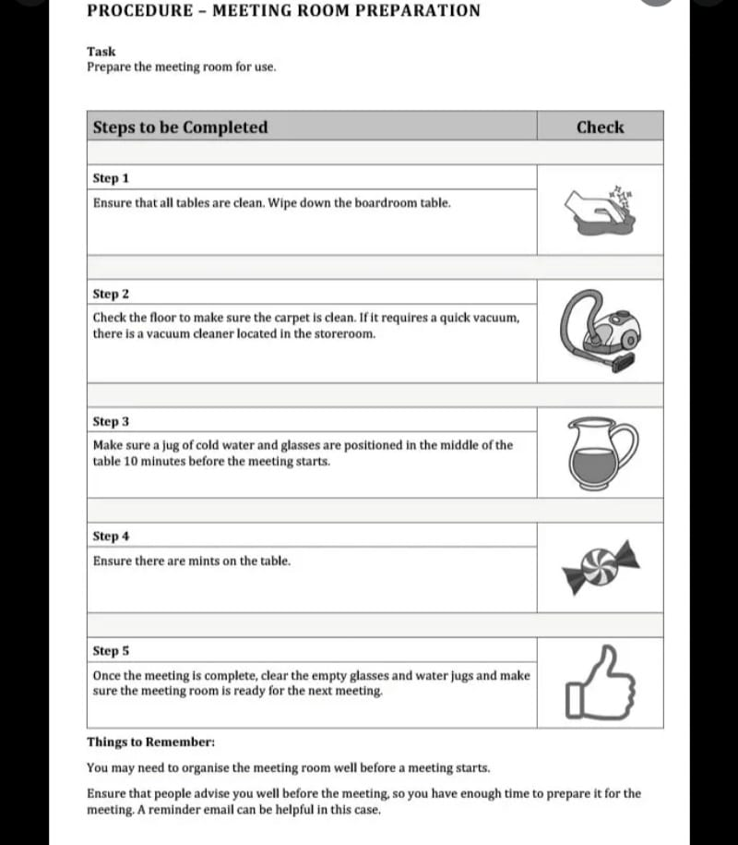

***Step 3:***

The class will then be given the following characteristics of a good manual prior to doing one of their own.

A good manual should make instructions easy to follow. It should,

1. Provide step-step sequence in the correct order
2. Follow the timing of the actual operation (where applicable)
3. Provide visual stepping stones
4. Avoid lengthy paragraphs
5. Use every day words and terms

***Step 4:***

Students will then be placed in pairs to create a manual based on a product/service choice. The following instruction will be given:

1. Product/service must be clearly identified
2. Steps must be clear, concise and in order
3. There must be some sort of visual aid
4. There must be at least five steps to the process.

***Step 5:***

The manuals will be collected and accessed for;

1. Clarity of steps/conciseness and use of graphics (content) 12 marks
2. Use of language 7 marks
3. Creativity 6 marks

Total 25 marks

The best three will be shared with the class for motivation.

***EVALUATION 2:***

**Name:**  Patricia Clarke

**Subject:**  English Language

**Grade**: 10 E AND C   
**Time**: 5*40 mins

**Date:** May 16-20, 2022

**Topic**: Expository Writing

***General Objective:***

To help students to understand the different types of expository pieces.

***Specific Objectives:***

At the end of this lesson, students will be expected to:

1. Make presentations on the different types of expository pieces (Assignment given for Easter Break)
2. Critique the presentations of each group to show understanding of the concepts.
3. Complete a ten question pop quiz ( a review)
4. Understand how to write the introduction of an essay (step-step process)

***Week’s Affirmation: The only way to reach the top is to challenge yourself.***

***Day 1– PRESENTATIONS***

***Step 1:***

The class will begin with students getting in their groups and making final preparations for the presentations.

***Step 2:***

The rubric and peer evaluation sheets will be issued so that students will engage in the process (Sheets previously used in class)

***Step 3:***

First three presentations will be done (five minutes each) after which we will pause to do the peer evaluations. This will be a five minutes pause as well. Teacher will give feedback to those groups at this time as well.

***Step 4:***

The next three presentations will be done at this time. At the end of the presentations, we will again do an evaluations.

***Step 5: (Culminating Activity)***

The lesson will culminate with teacher giving the class an overall feedback to include clarity where needed.

***DAY 2:***

***Step 1:***

I order to ensure students understand the different types of expository writing, the class will review in quiz format. The quiz will be given in the first session of the class.

***Step 2:***

The class will review the answers for the quiz openly. Clarity will be given for any misconceptions identified during this process.

***Step 3:***

The class will then move on to looking at writing the expository essay. We will begin with looking in details at what should be included in the introduction and how to write an effective introduction.

***EXPOSITORY- INTRODUCTION***

Like all essays, an expository essay begins with an [introduction](https://www.scribbr.com/academic-essay/introduction/). This serves to hook the reader’s interest, briefly introduce your topic, and provide a [thesis statement](https://www.scribbr.com/academic-essay/thesis-statement/) summarizing what you’re going to say about it.

***Hooks Appropriate for Expository Writing***

***Remember!!!***

1. Your hook should grab your reader’s attention
2. It can be a quote, a question, an anecdote, a shocking statistic, or even a rhetorical question.

***Thesis***

An effective thesis statement fulfills the following criteria

* + **Substantial**– Your thesis should be a claim for which it is easy to answer every reader’s question: “So what?”
  + **Supportable** – A thesis must be a claim that you can prove with the evidence at hand (e.g., evidence from your texts or from your research). Your claim should not be outlandish, nor should it be mere personal opinion or preference (e.g., “Frederick Douglass is my favorite historical figure.”) It tackles a subject that could be adequately covered in the format of the project assigned.
  + **Precise** – It is focused and specific. A strong thesis proves a point without discussing everything. It clearly asserts your own conclusion based on evidence. Note: Be flexible. It is perfectly okay to change your thesis!
  + **Arguable** – It should be contestable, proposing an arguable point with which people could reasonably disagree.
  + **Relevant** – If you are responding to an assignment, the thesis should answer the question your teacher has posed. In order to stay focused, pay attention to the task words in the assignment: summarize, argue, compare/contrast, etc.
  + **Aware of Counters**– It anticipates and refutes the counter-arguments.

***Step 4:***

The class will then move on to look at a sample introduction, looking specifically at the thesis statement.

***SAMPLE INTRODUCTION***

**Topic:**

**Staycations allow us to explore the diversity of Jamaica’s natural and cultural heritage. Why it is important for Jamaican’s to experience the Jamaican tourism product?**

“Ooh, I met a girl this morning, she was love at first sight. Ooh, I met a girl this morning, she was beauty to my eyes…”

The popular Jamaican artiste, Chronixx, has immortalized and personified the beauty of our natural heritage of our island, Jamaica, when he sang, “…she was beauty to my eyes, smile girl smile, smile for me Jamaica…” Jamaica is, no doubt, one of the leading tourism countries in the western hemisphere. It is imperative that Jamaicans know what it is that attracts tourists to the island so that they themselves can help to market the product. Staycationing is a great vacationing option for Jamaicans as it is an opportunity for us to enjoy what others can only dream of enjoying; it reunites us with the beauty of our island, and it is less of a hassle.

***Step 5: (Culminating Activity)***

The lesson will culminate with students writing thesis statements to support the following topics.

***Expository Topics***

1. Explain why someone you know should be regarded as a leader.
2. Explain why parents are sometimes strict.
3. If you had to be an animal, which would you be and why?
4. Explain why you especially enjoy a particular teacher.
5. Explain why some students are forced to leave school once they are sixteen.
6. Explain the likely [consequences](https://www.thoughtco.com/ethical-dilemmas-for-essay-topics-1856982) of skipping school.
7. Describe the likely consequences of doing poorly in school.
8. Explain the likely consequences of being sexually active without using protection.

***EVALUATION 2:***

***ADDENDUM***

***Quiz (10 U)***

1. Summarize the problem and solution organization pattern by filling in the following:

In this type of organizational pattern, a _________________ is presented with some indication of how it can be ______________. Some of the signal words that are used to identify the problem are _____________, __________________, ______________________ and _________________.

As it relates to the solution, some signal words are __________________, ___________________, _______________ and _________________________.

1. **Read each short paragraphs and fill in the missing boxes with the appropriate information**.

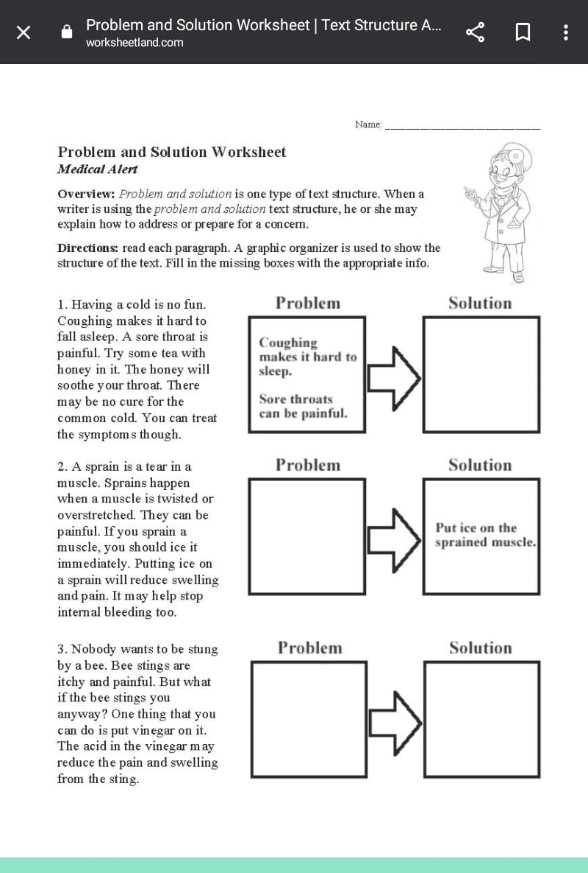

***QUIZ – 10 C and E***

***TYPES OF EXPOSITORY ESSAY – AN OVERVIEW***

1. Expository writing should give information that is __________________
2. What is the author’s purpose in an expository text? ___________________
3. List three examples of expository writing:
4. ____________________________
5. ____________________________
6. ____________________________
7. List the six types of expository essays as discussed in class.
8. ___________________________
9. ___________________________
10. ___________________________
11. ___________________________
12. ___________________________
13. ___________________________
14. The block and alternative organizational structure is unique to which type of expository essay_________________________________?
15. If I wish to teach someone how to do something, which type of expository essay would be effective ________________________________?
16. As a result of, consequently, because, since and therefore are signal words for ______________________________?
17. __________________________ is the specific facts, examples and other details used to support the arguments in your essay.

***True or False***

1. Only three of the six expository essay types are factual __________________________
2. All expository essays must have a thesis statement ______________________________
3. The first sentence of each body paragraph is your thesis statement _________________
4. Your introduction should have hook, background and thesis______________________
5. Expository writing and informative writing are the same _________________________

**20 marks**